# **AN APPROACH NOTES FOR RECORD KEEPING OF DOCUMENTS**

This project aims to transform the traditional paper-based procurement process into a fully digital workflow system, streamlining the entire procure-to-pay cycle. The focus is on digitizing all vendor documentation—including invoices and supporting materials—through three primary channels: a dedicated vendor portal **(Nimble S2P**), a digital scanning center, and email submissions.

This approach will create a centralized digital repository for procurement documents, enabling efficient tracking through a unique document numbering system, while maintaining secure physical archives of original documents. The system integrates with **SAP** for gate entries and implements a structured document management process, supported by qualified personnel at multiple checkpoints. This digital transformation will enhance document accessibility, reduce processing time, minimize paper usage, and improve overall procurement efficiency while maintaining robust audit trails.

## **Document Upload Modes**

**1. Vendor Portal**

* **Process:** The vendor will upload invoices and supporting documents to the **Nimble S2P portal**. Upon vehicle receipt, gate entry will be recorded in **SAP**. Hard copies will be handed over to the digital scanning team, who will check if the documents have been uploaded on the portal.
  + **If all documents are uploaded:** No scanning is required.
  + **If some documents are missing:** The team will scan missing documents, attach them to the digital file, add the gate entry number, and send the hard copy to the record room for archiving.

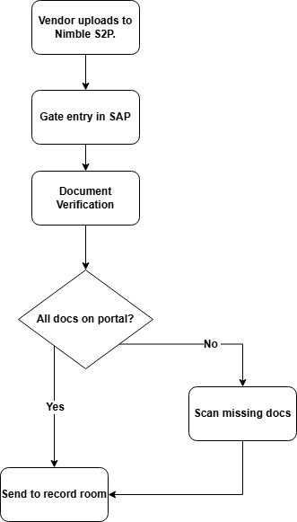

### **2. Digital Center and Scanning Center**

* **Process:** If the vendor has not uploaded documents on Nimble S2P and hasn't sent them via email, invoices and supporting documents will be brought to the scanning center by the driver. These documents will be uploaded at the center, and the hard copies will be sent to the record room.

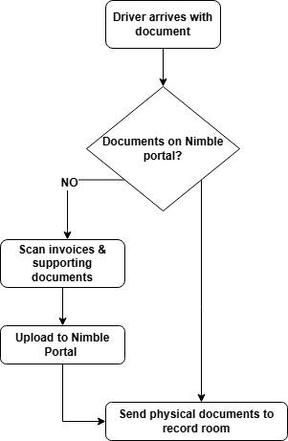

### **3. Email Submissions**

* **Process:** When the invoice is sent via email to the buyer, it will be forwarded to the digital center. At the center, the documents will be uploaded, and any hard copies carried by the driver will be archived in the record room. **Internal and external documents** will follow this mode, and the Nimble portal will generate a code with complete document information.

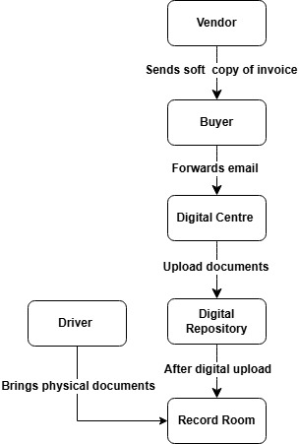

## **Document Numbering Format for Hard Copy Archive**

### **Format:**

<G.E.N> <DD MM><X> <SOURCE><SR. NO><BUCKET>

#### **Example:**

**2400178819/0912/M/99/99999/100**

#### **Code Description:**

* **G.E.N:** Gate Entry Number (10 digits)
* **DD MM:** Date of Gate Entry (DDMM format)
* **X:** Service/Material/Non-PO Code
  + **M** = Material
  + **S** = Service
  + **N** = non-PO
* **Source:** Source of document digitization
* **Sr. No:** Serial number of the document
* **Bucket:** Bucket number where records are stored

## **Manpower Requirements**

|  |  |  |  |
| --- | --- | --- | --- |
| **Position** | **Qualification** | **Experience** | **Salary** |
| **Scanners** | PGDCA, Master's Degree, B.Tech | 1 year in digitization | ₹20,000 |
| **Record Keeper** | Same as Scanner | 4 years as librarian/record keeper | ₹25,000 |
| **Coordinator** | B. Tech | Minimum 4 years | --- |

### **Scanning Locations**

* **Gate-4**
* **Gate-1**
* **Project Building**

### **Resource Requirements**

* **Total Scanners Needed:** 6
* **Bar code Printers Required:** 6
* **Total Personnel Needed:** 13

